Name :- Sanket Chandrashekhar Harvande

Roll no :- 19

Experiment No :- 01

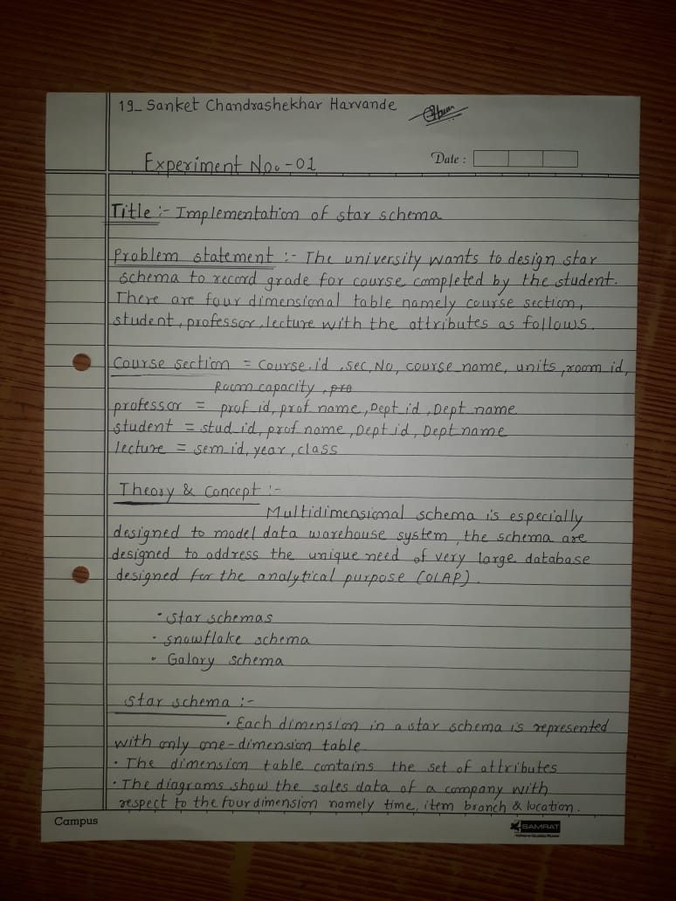

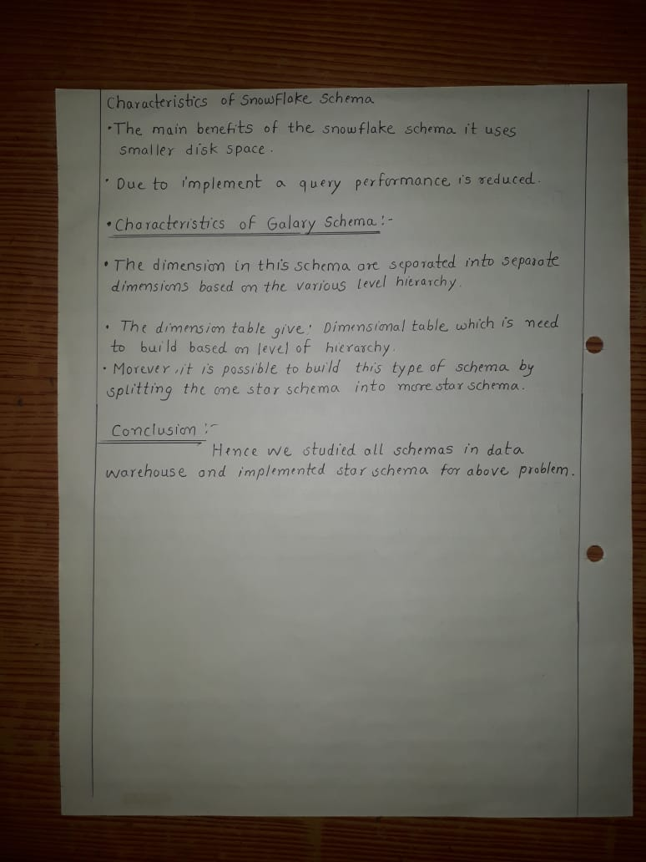

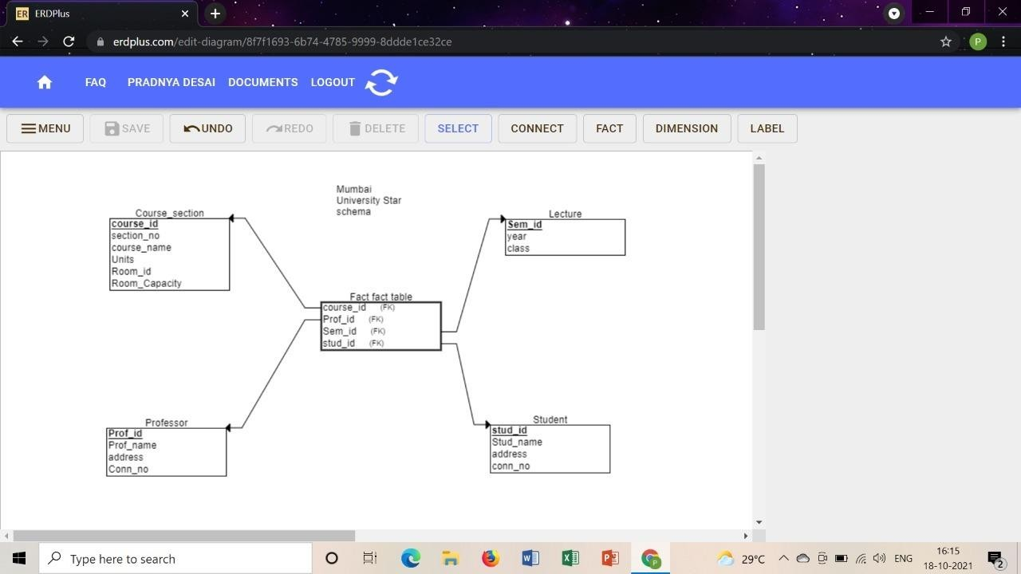OUTPUT :